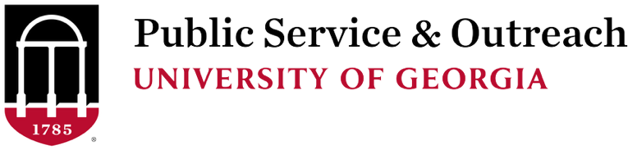

PSO STUDENT SCHOLARS APPLICATION GUIDANCE
We are excited that you are considering applying for the PSO Student Scholars program. We hope the following information will assist you as you complete the application process.

Application Form
The application form is straightforward and asks mainly for general information. Applicants should focus on updating their resume and providing an honest and straightforward answer to the essay questions explaining their interest in the PSO Student Scholars program. Applicants will be expected to:
- Provide basic information (name, address, major, etc.)
- Upload a current copy of their resume
- Submit a 250-500 word statement explaining;
  - Your motivations to participate in the PSO Student Scholars program;
  - Your preference and rationale for possible internship placement(s);
  - How participation relates to your career/academic goals
- Agree to the program requirements

Current Transcript
Applicants should request this document with sufficient time for it to be delivered to the Office of Service-Learning by the application deadline.
- Applicants may submit an official transcript (via the Registrar’s Office) to jhpodvin@uga.edu; alternatively, applicants may submit a student-generated (unofficial) transcript.

Faculty/Staff Reference Form
Applicants are encouraged to provide faculty/staff with the recommendation form as early as possible (you do not have to wait until you submit your application to share the reference form). Ideally, the individual providing your reference will be working on the form at the same time that you are completing your application.
The Faculty/Staff Reference form is expected to be submitted by the application deadline.

Program Interview
Program finalists will be interviewed during the month of April. Program interviews are professional interviews with PSO faculty/staff in various units. The typical interview lasts about 15 minutes (10-12 minutes of general questions, followed by 2-3 minutes for applicants to ask questions). All applicants will be noticed of acceptance/deferral prior to the end of the semester. Program applicants will be expected to commit to the program by late May.

Questions?
We are more than happy to answer questions about the application process, program, internship, or the Division of Public Service and Outreach. If you have questions, please contact OSL Assistant Director Joshua Podvin, jhpodvin@uga.edu, 706-542-4511.
Students are welcomed (and encouraged) to discuss their interest with current/former PSO Student Scholars program participants. Please contact jhpodvin@uga.edu if you would like to speak with a current PSO Student Scholar.
Application forms and information are linked from the Public Service & Outreach page at: https://outreach.uga.edu/programs/pso-student-scholars/.

